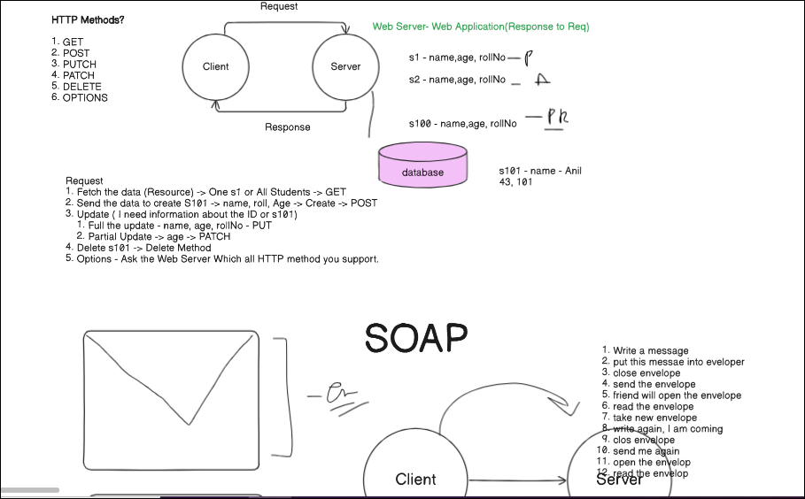

SOAP - 6-7%
Simple object access protocol
- XML
- Transfer the data from client to server.
- Client -> Server
- It uses XML Information Set for its message format HTTP, SMTP also supported.
- Best suited for enterprise-level applications.
- Provides built-in security features through WS-Security.
- Message sent -> It takes lot of bandwidth.
  - open the message
  - close the message
  - envelope
Project#1
- API Documentation
  - ﻿www.dataaccess.com/webservicesserver/NumberConversion.wso?op=NumberToWords
- Request -> Fetch the Details
  - URL - ﻿www.dataaccess.com
    - Endpoint - /webservicesserver/NumberConversion.wso
    - Full URL - host+endpoint -> ﻿www.dataaccess.com/webservicesserver/NumberConversion.wso
  - HTTP Method
    - POST
  - Auth ?' - NO
  - Cookie - NO
  - Header? - Content-Type: text/xml; charset=utf-8
  - Payload?
<?xml version="1.0" encoding="utf-8"?>
<soap:Envelope xmlns:soap="http://schemas.xmlsoap.org/soap/envelope/">
<soap:Body>
<NumberToWords xmlns="http://www.dataaccess.com/webservicesserver/">
<ubiNum>unsignedLong</ubiNum>
</NumberToWords>
</soap:Body>
</soap:Envelope>
- Parameter? ? - NA
- Response ->
  - Status Code
  - Body -> Verify the Response
  - Headers
  - Response time
XML
- XML stands for eXtensible Markup Language.
- XML is a markup language much like HTML.
- XML was designed to store and transport data.
- Looks like text file with tags.
<note>
<to>Tove</to>
<from>Jani</from>
<heading>Reminder</heading>
<body>Don't forget me this weekend!</body>
</note>
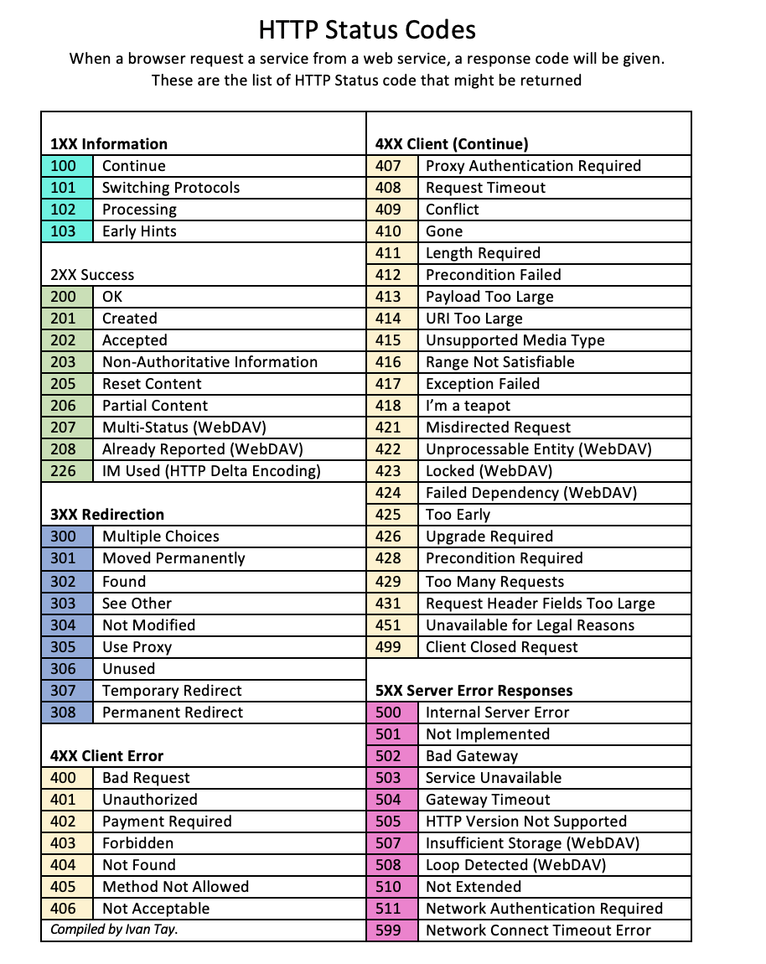
Payload -> Data that you want to send to Server -

SOAP Revise 6%
- Simple object access Protocol.
- XML based
- More Secure
- Heavy Bandwidth.
- Transfer the data from client to server.
- Complex Structure and WSDL(Web Services Description Language)
- SOAP compliant transactions are critical.
- Complex operations and formal contracts between client and server.
- Envelope
  - header
  - body
  - Footer
<?xml version="1.0" encoding="utf-8"?>
<soap:Envelope xmlns:soap="http://schemas.xmlsoap.org/soap/envelope/">
<soap:Body>
<NumberToWords xmlns="http://www.dataaccess.com/webservicesserver/">
<ubiNum>unsignedLong</ubiNum>
</NumberToWords>
</soap:Body>
</soap:Envelope>
Problem -> Consume more Bandwidth(over the internet)

